Configure Classic Load balancer.
Login to AWS account
Search for Loadbalancer - Ec2 Feature
Scroll down for Classic Load Balancer
Create
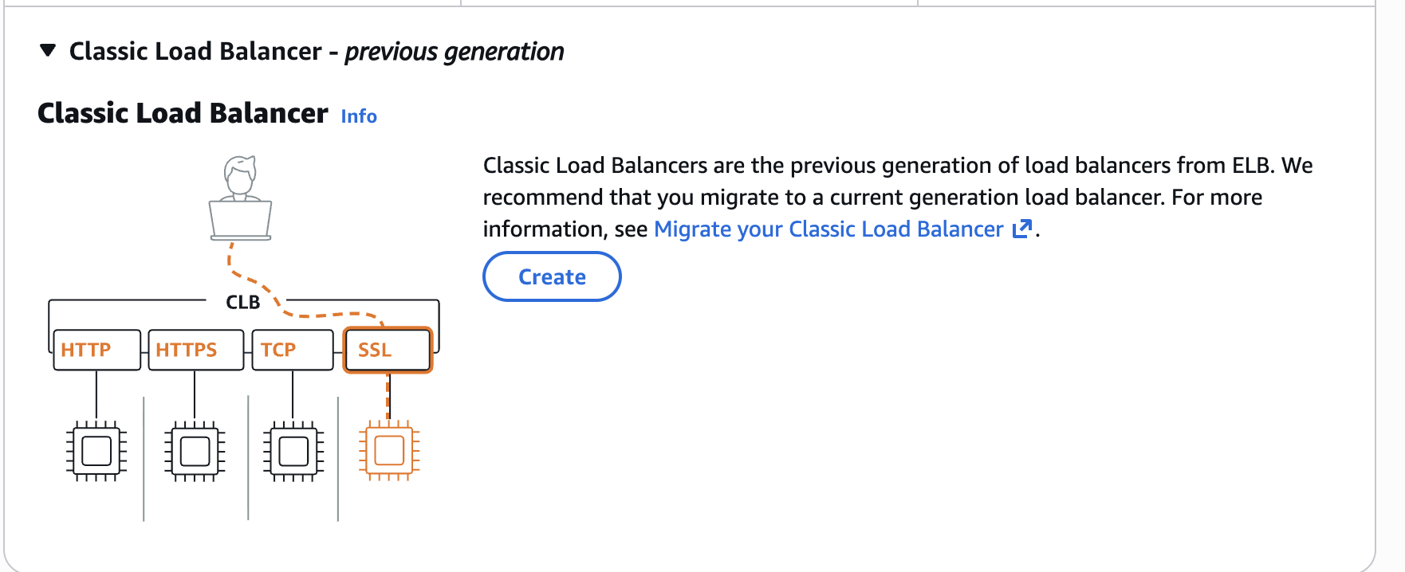
Give the Name for CLB
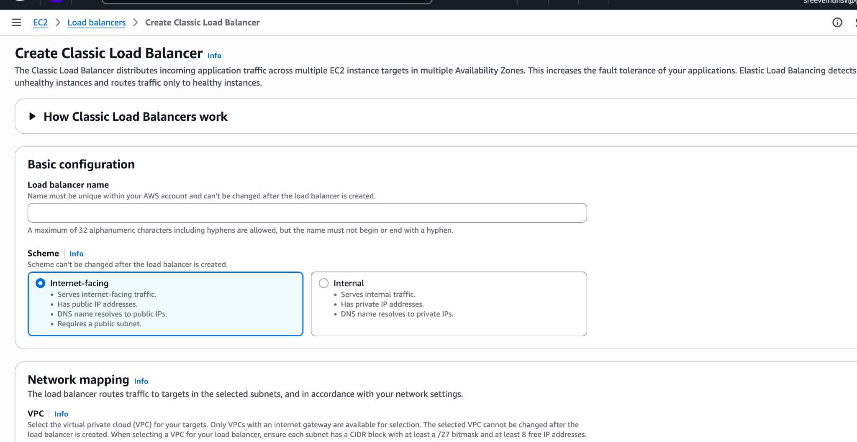
Select the default VPC
Select two different Zone as below
Us-east-1a & Us-east-1b
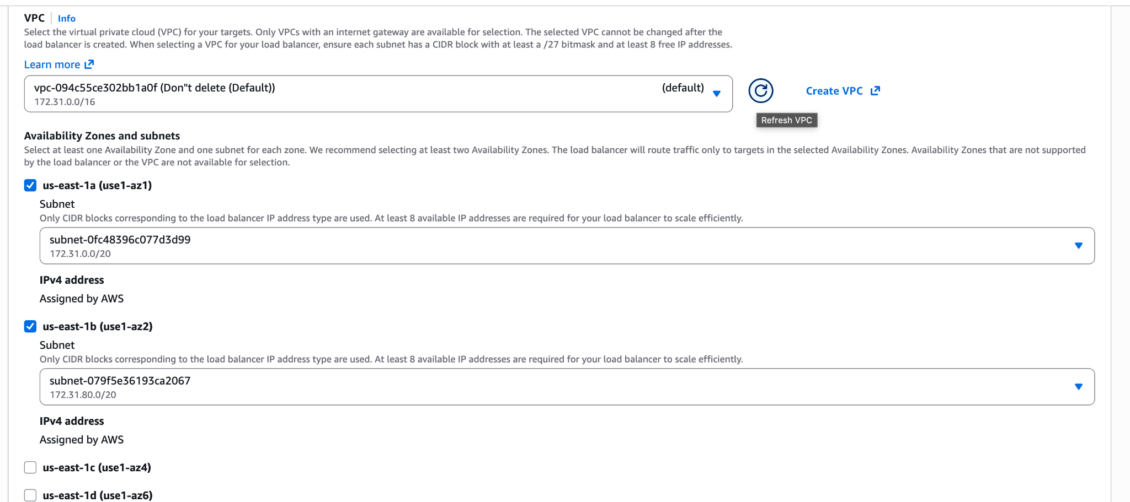
Keep security as Default.
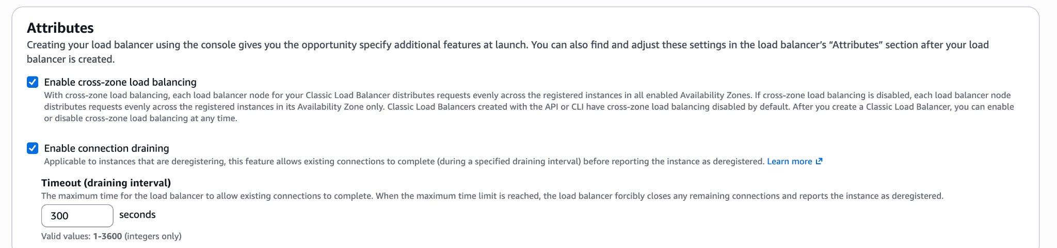
Then Create.
→ Now Create 2 Ec2 Instances in the same region - us-east-1a.
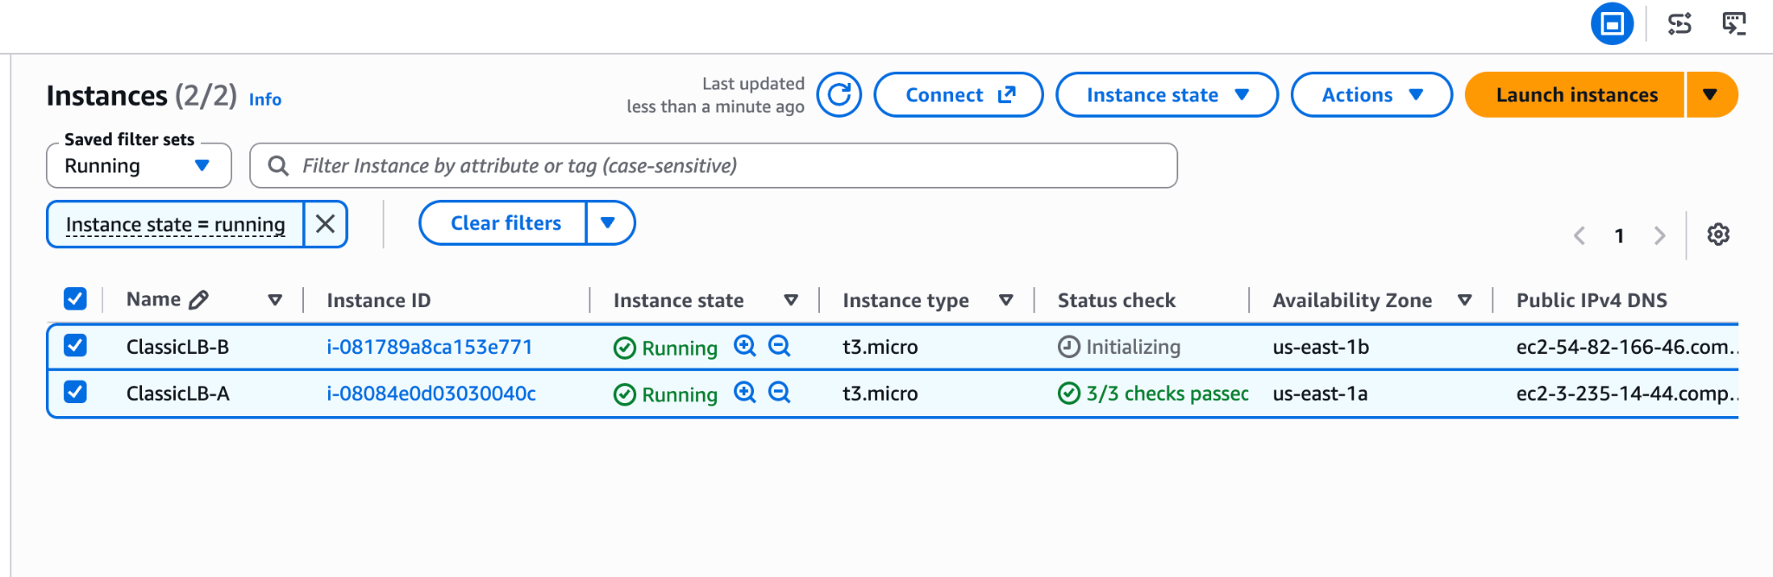
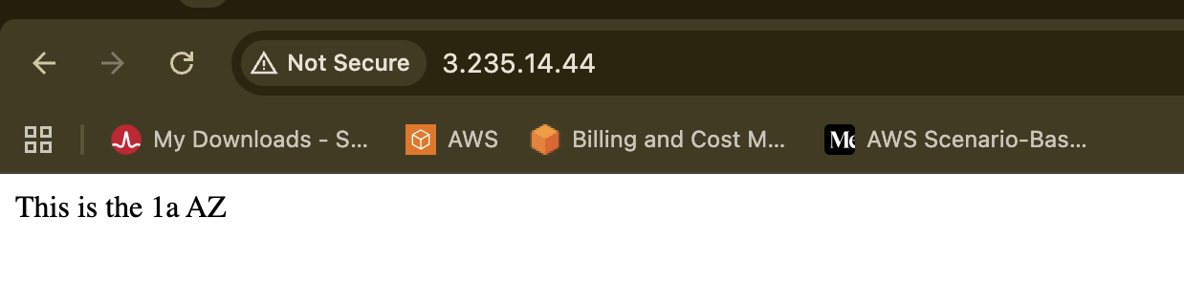
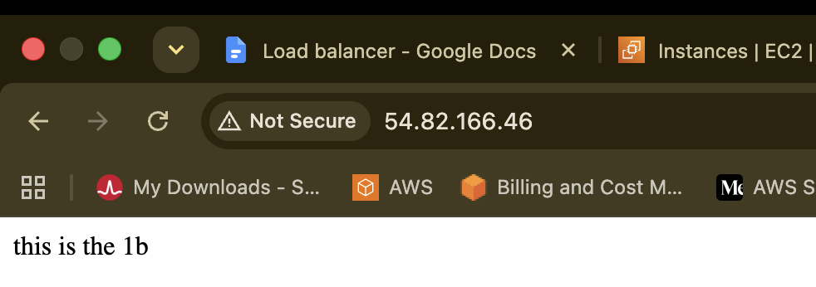
Manage instance in LoadBalancer select both
ClassicLB-A
ClassicLB-B
Then Select
There will be a DNS Link would be generated make sure its
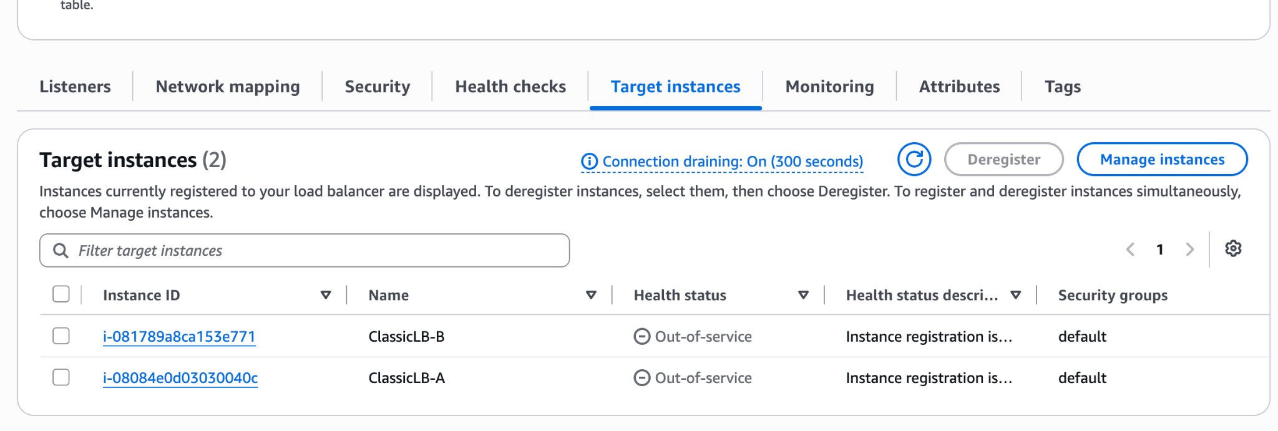
Go back to the Load Balancer Dashboard check the status is 2 of 2 with “Active” in status
Look for DNS copy then past in new browse for output
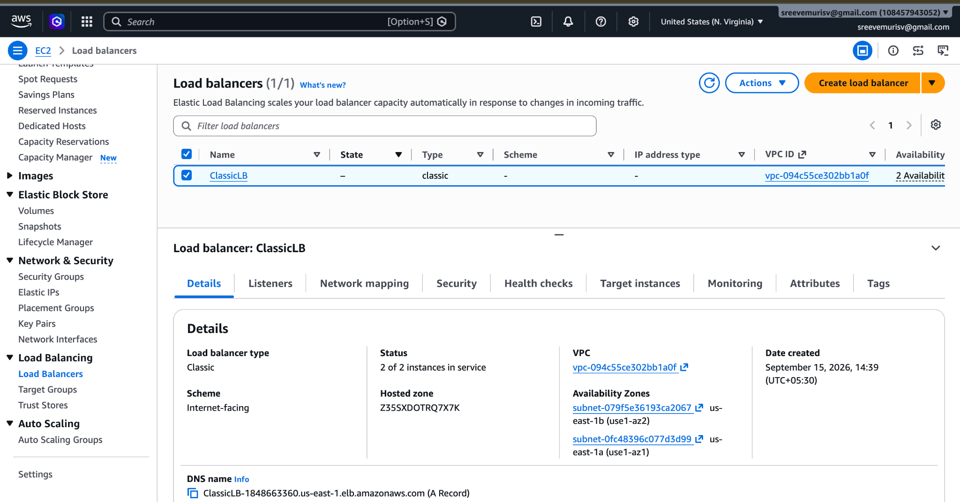
DNS: http://classiclb-1848663360.us-east-1.elb.amazonaws.com/
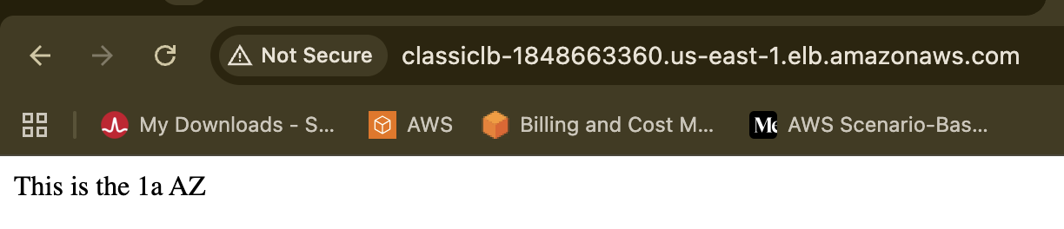
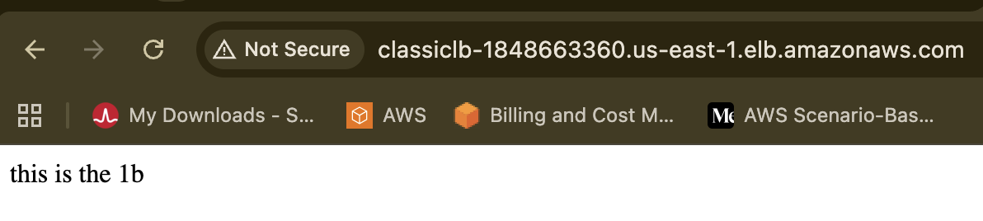
Configure Application Load balancer.
Create the Application Load Balancer by creating a new one.
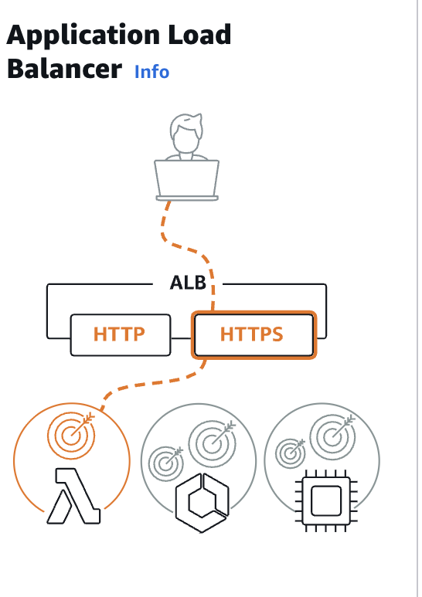
Create the Target Group of AZ 1a and 1b
And launch the Application LB
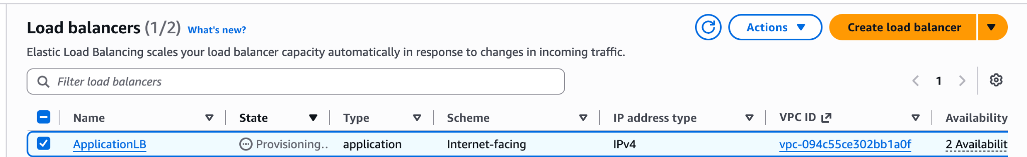
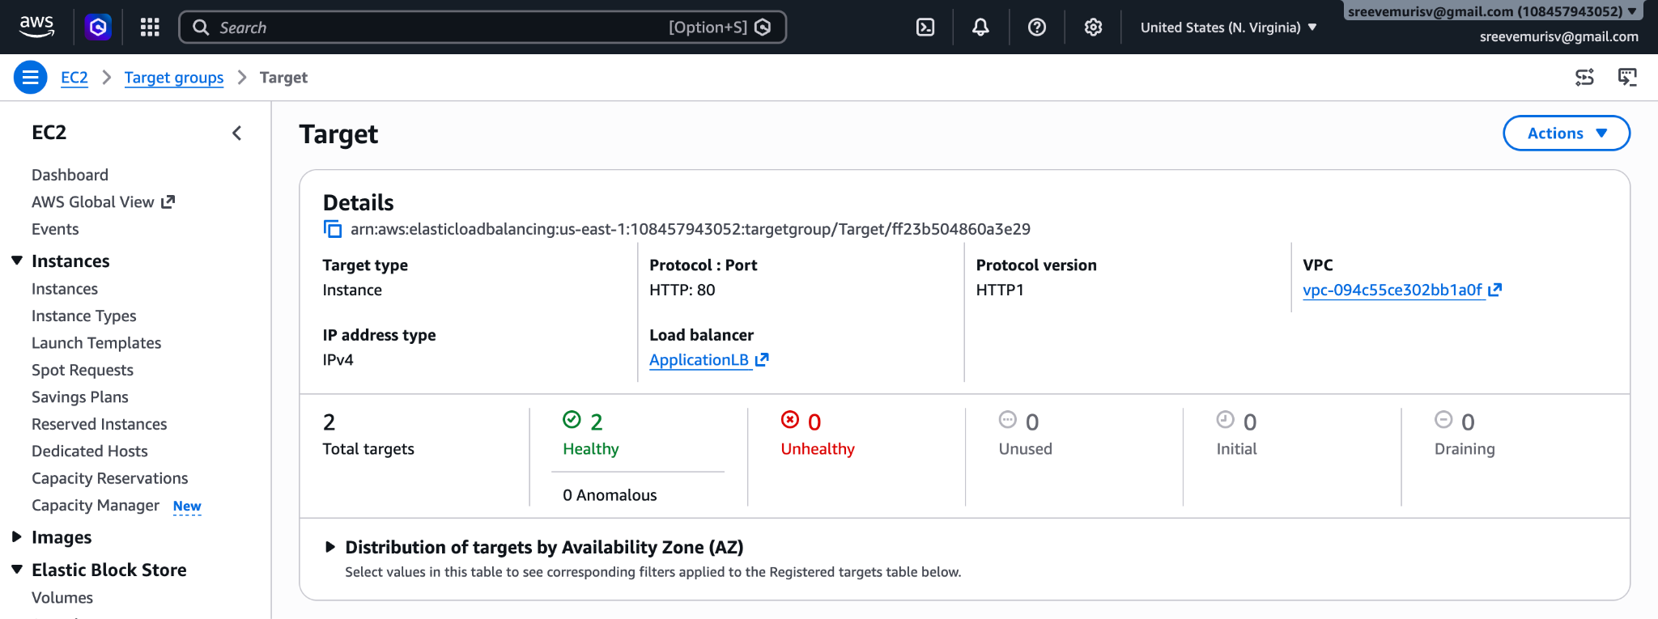
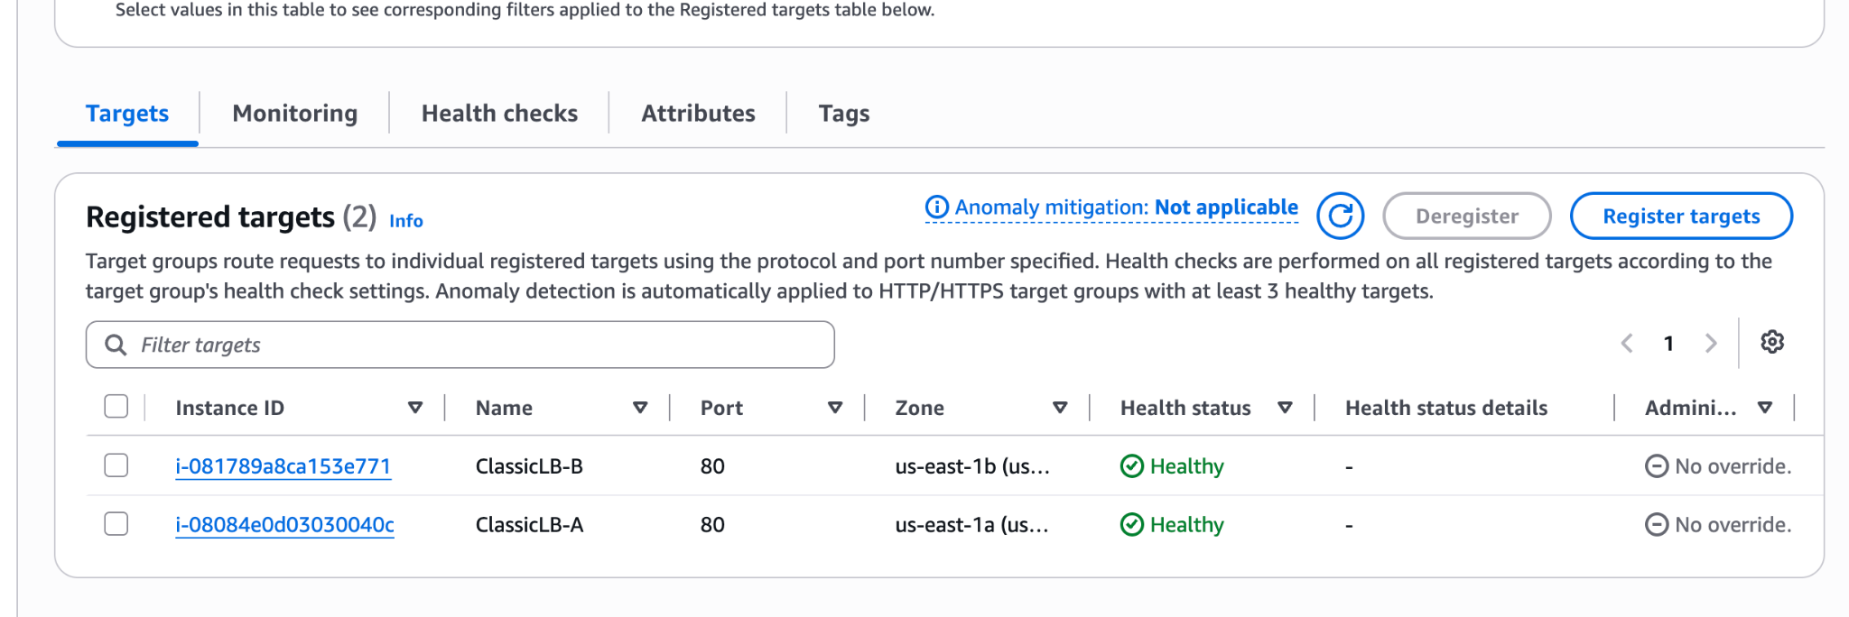
Back to DashBoard (Loadbalancer) copy the DNS of ApplicationLB
DNS: ApplicationLB-1563098494.us-east-1.elb.amazonaws.com
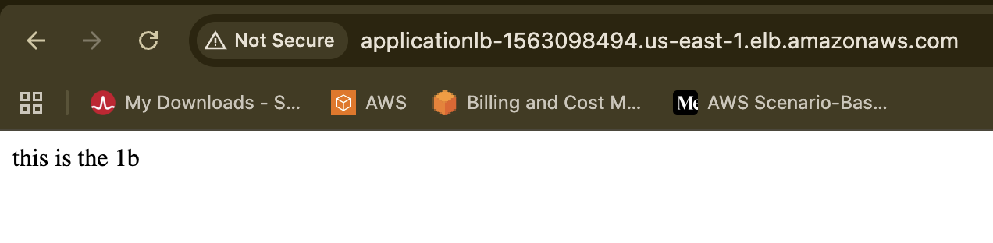
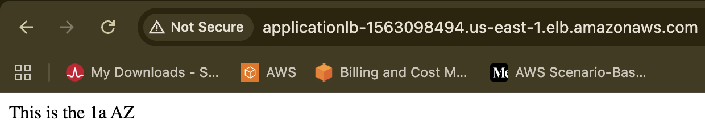
Configure Network Load balancer.
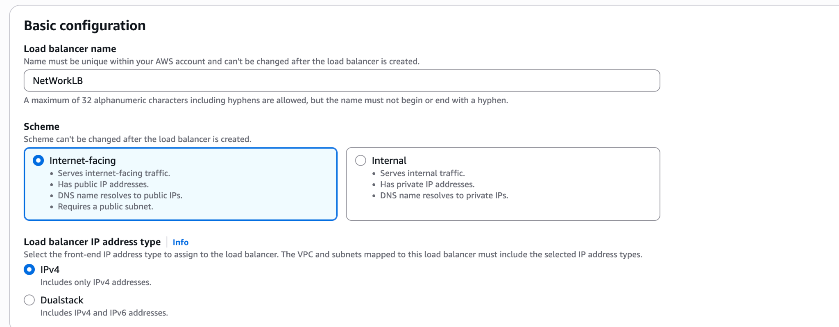
Create the Target group name as NLB with TCP 80
Link with the NetWorkLB
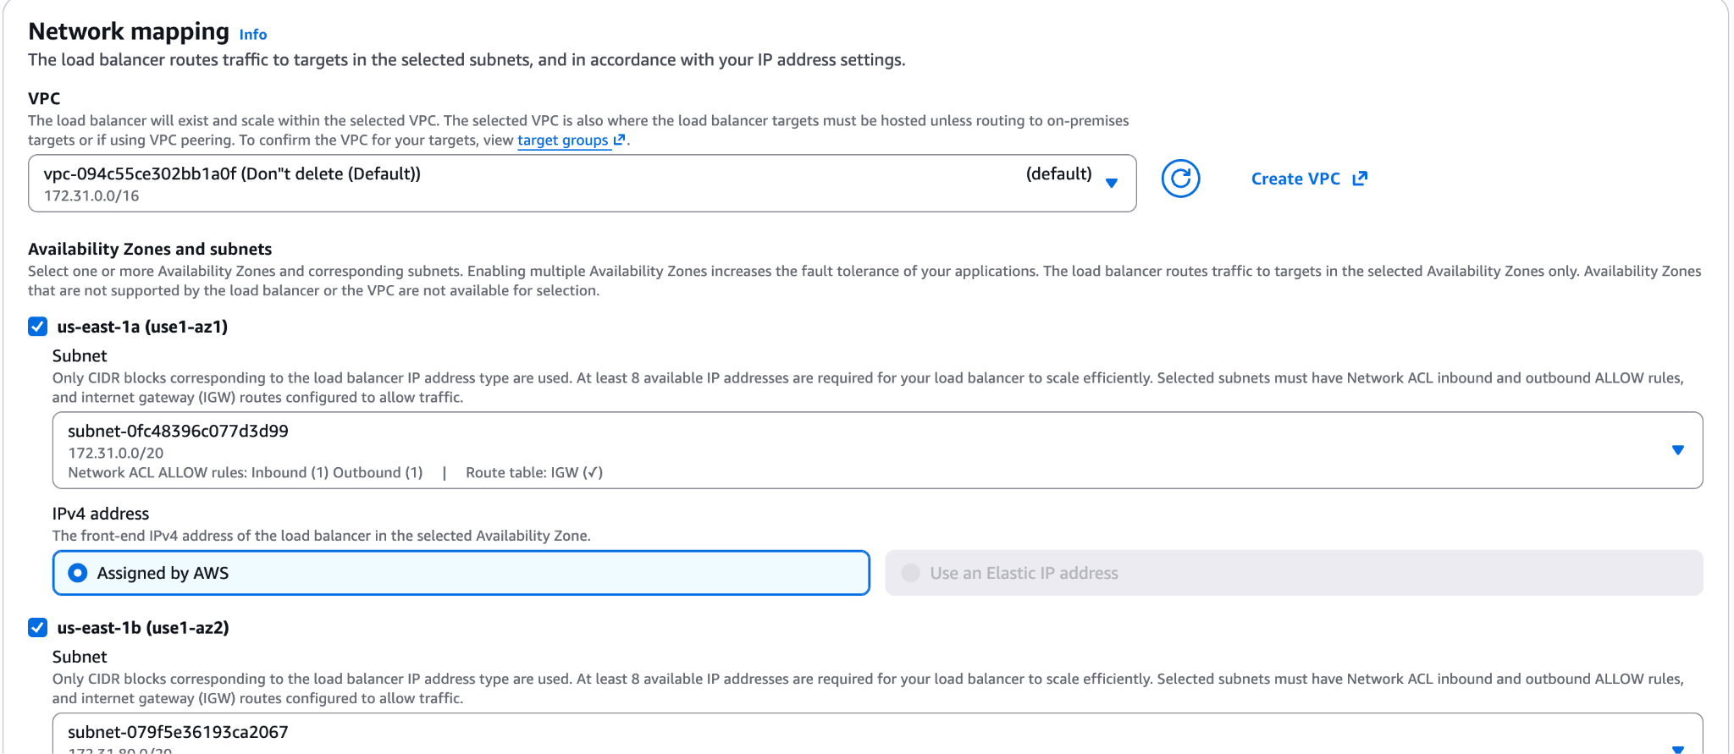
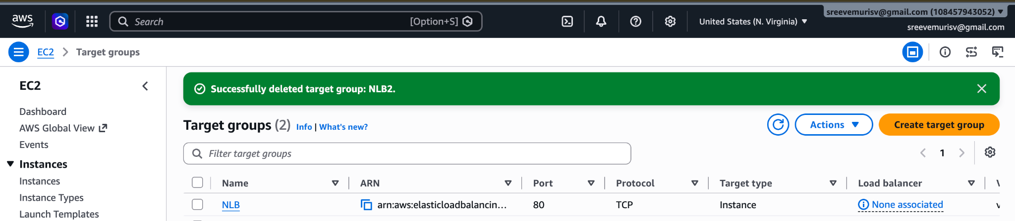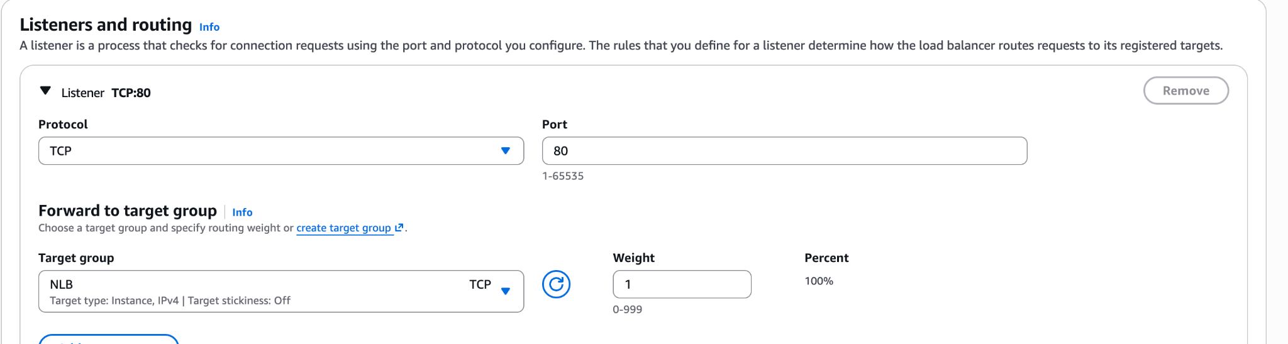
Attach SSL for application load balancer.
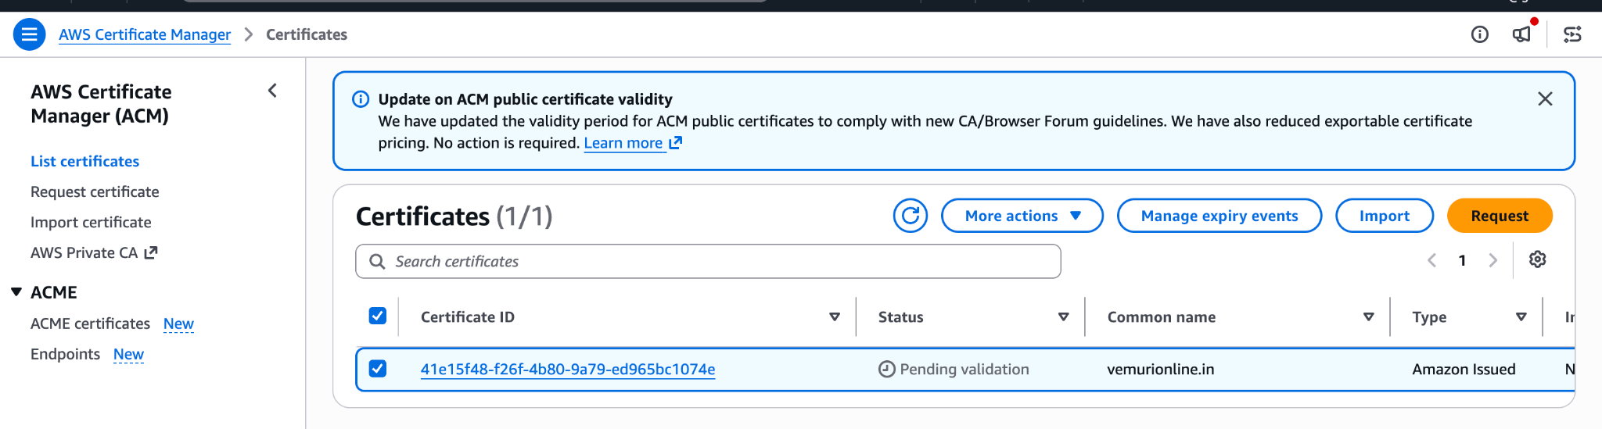
COpy the CNAMe , CValue into GOdaddy
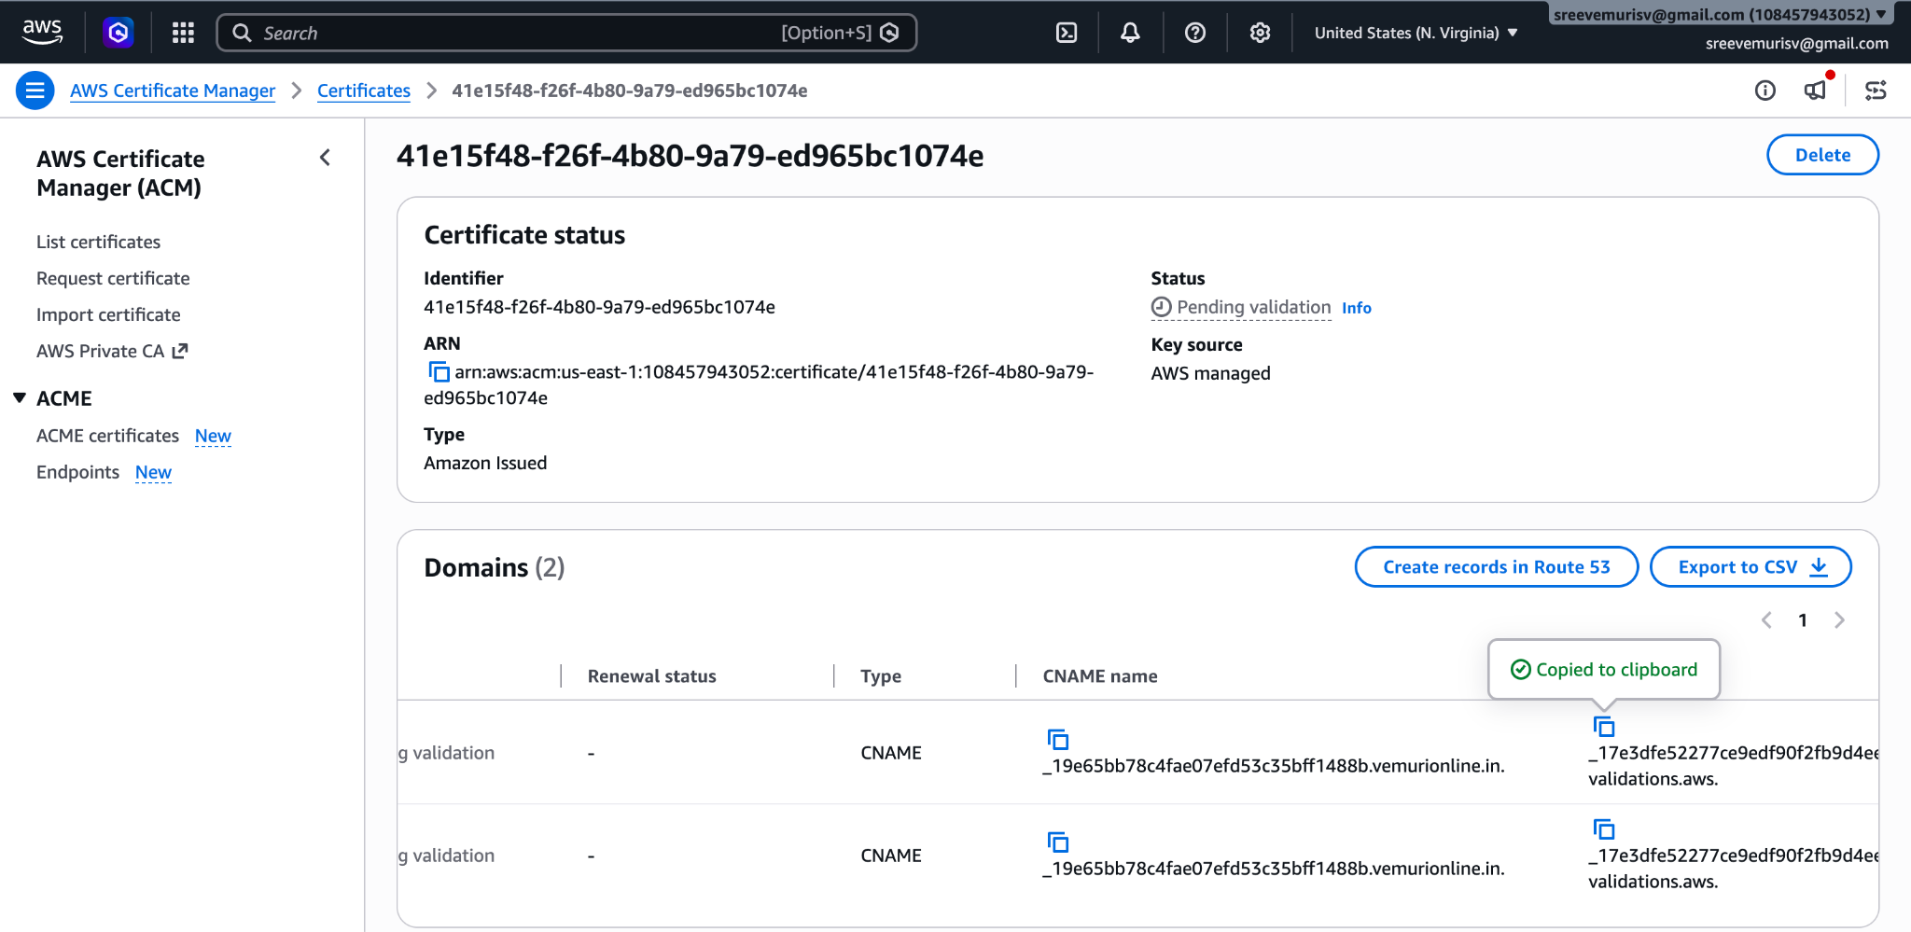
CNAME:
_19e65bb78c4fae07efd53c35bff1488b.vemurionline.in.
CVALUE:
_17e3dfe52277ce9edf90f2fb9d4eee9d.wzccmgtwzk.acm-validations.aws.
Navigate to GODaddy → DNS → DNSRecords → Add NewRecords
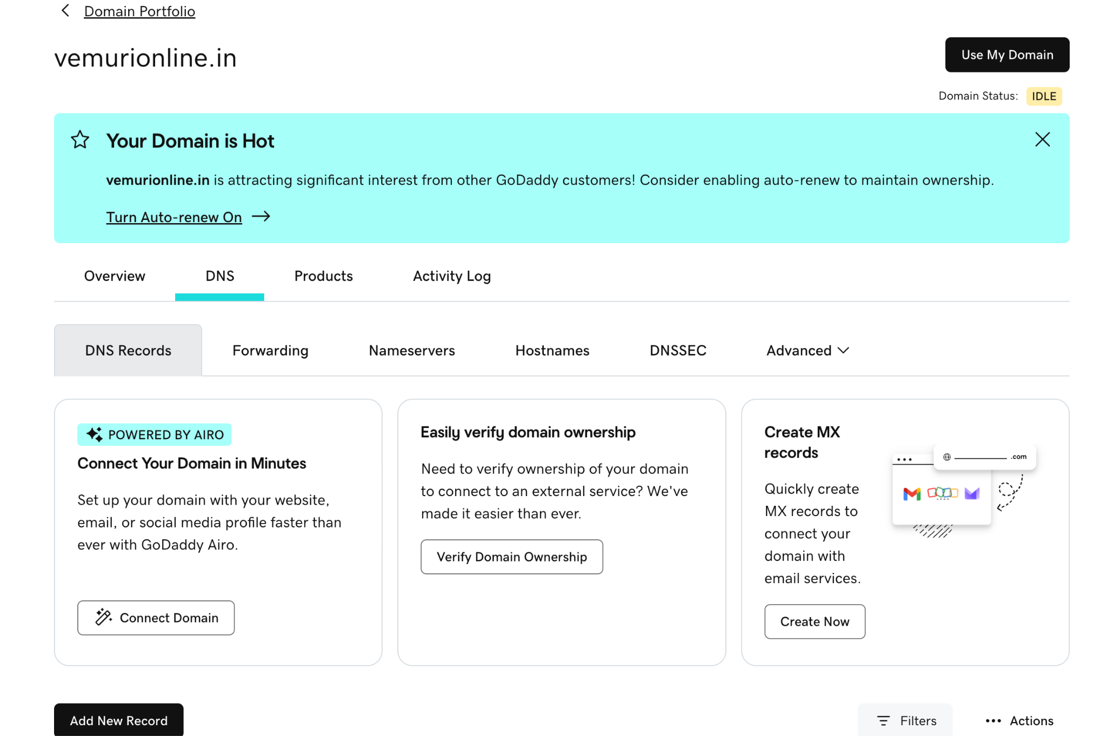
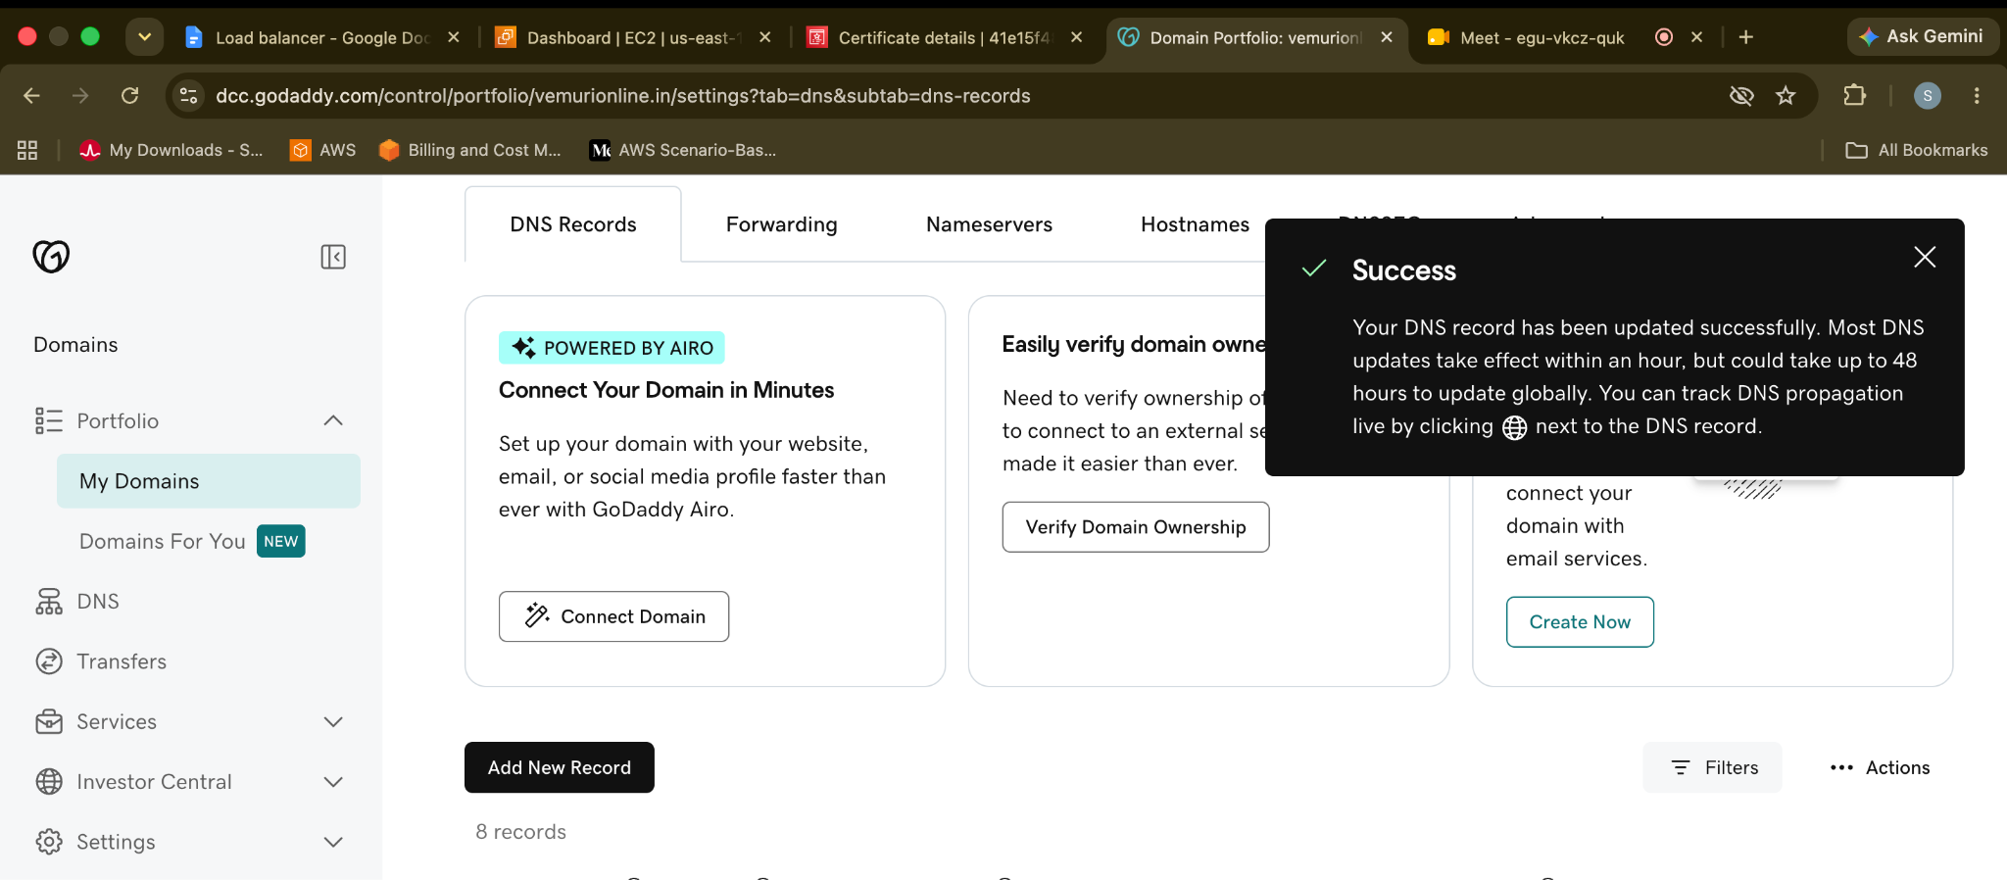
Now from the pending status to Issued
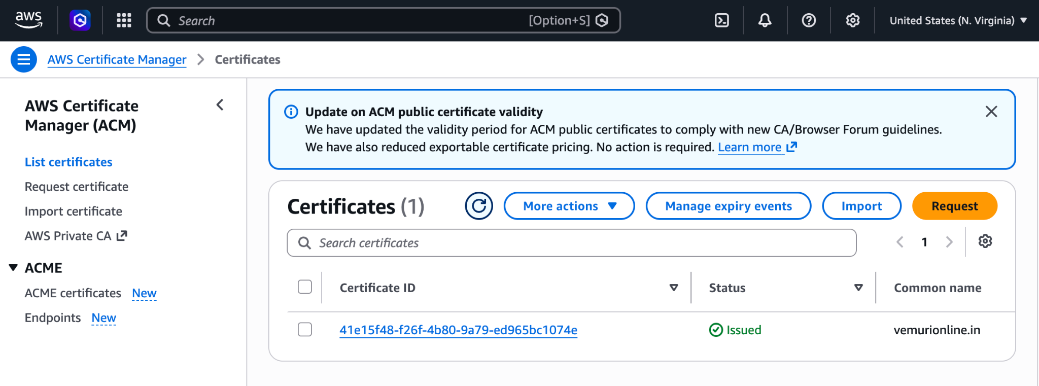
Here we have edited the Listeners and rules
1) we created the HTTPS with 443 port and given TargetName
2) use HTTP with the
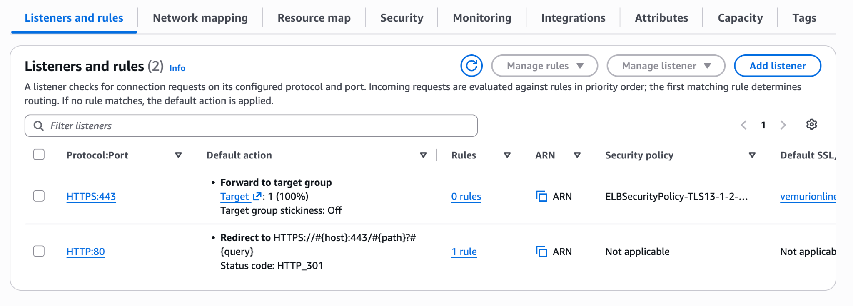
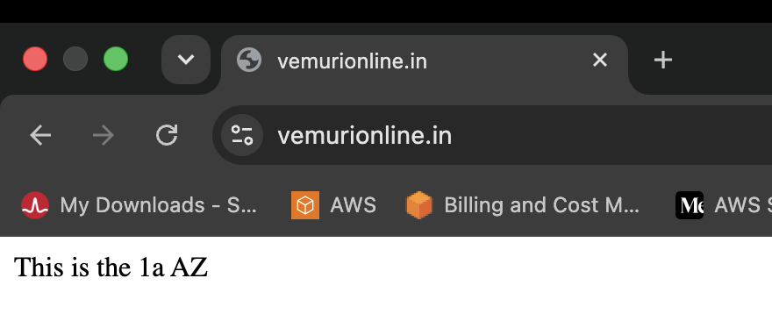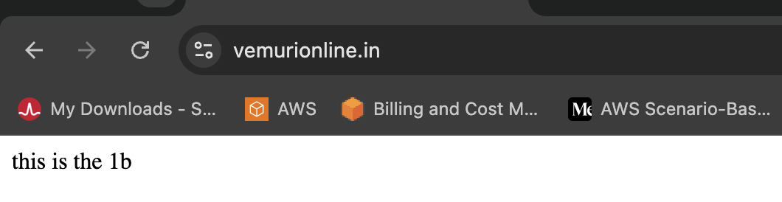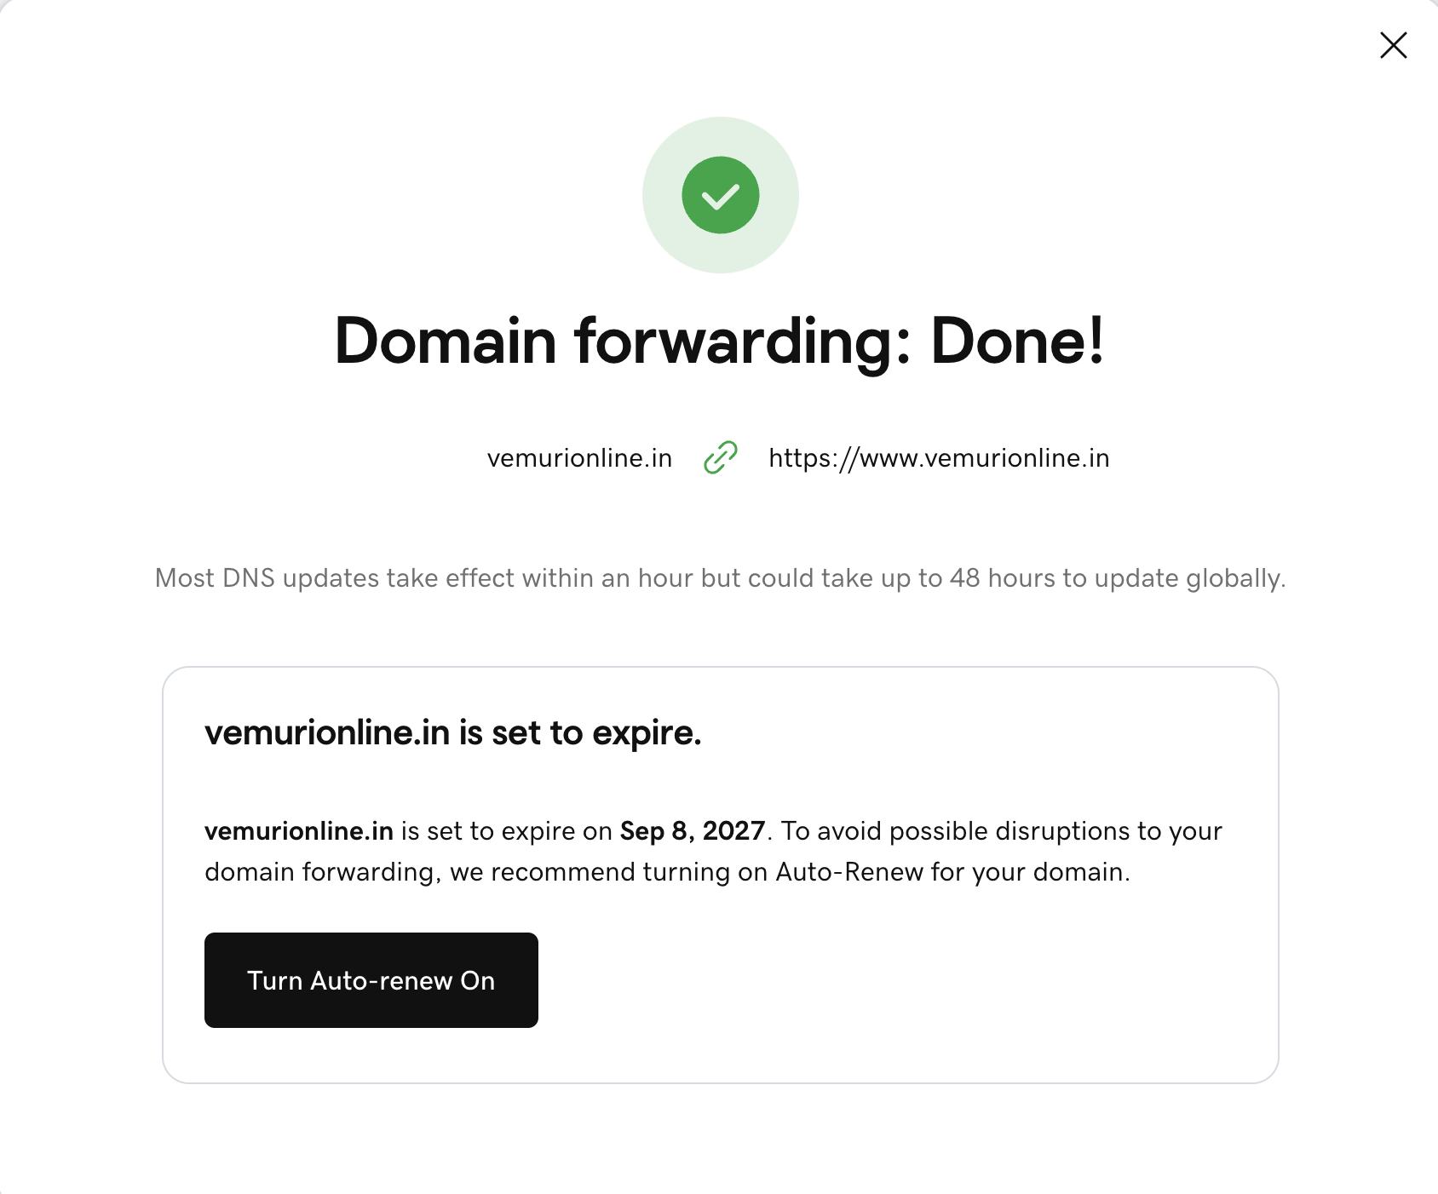
Now check the https://www.vemurionline.in in the new browser.
Map Application load balancer to R53.
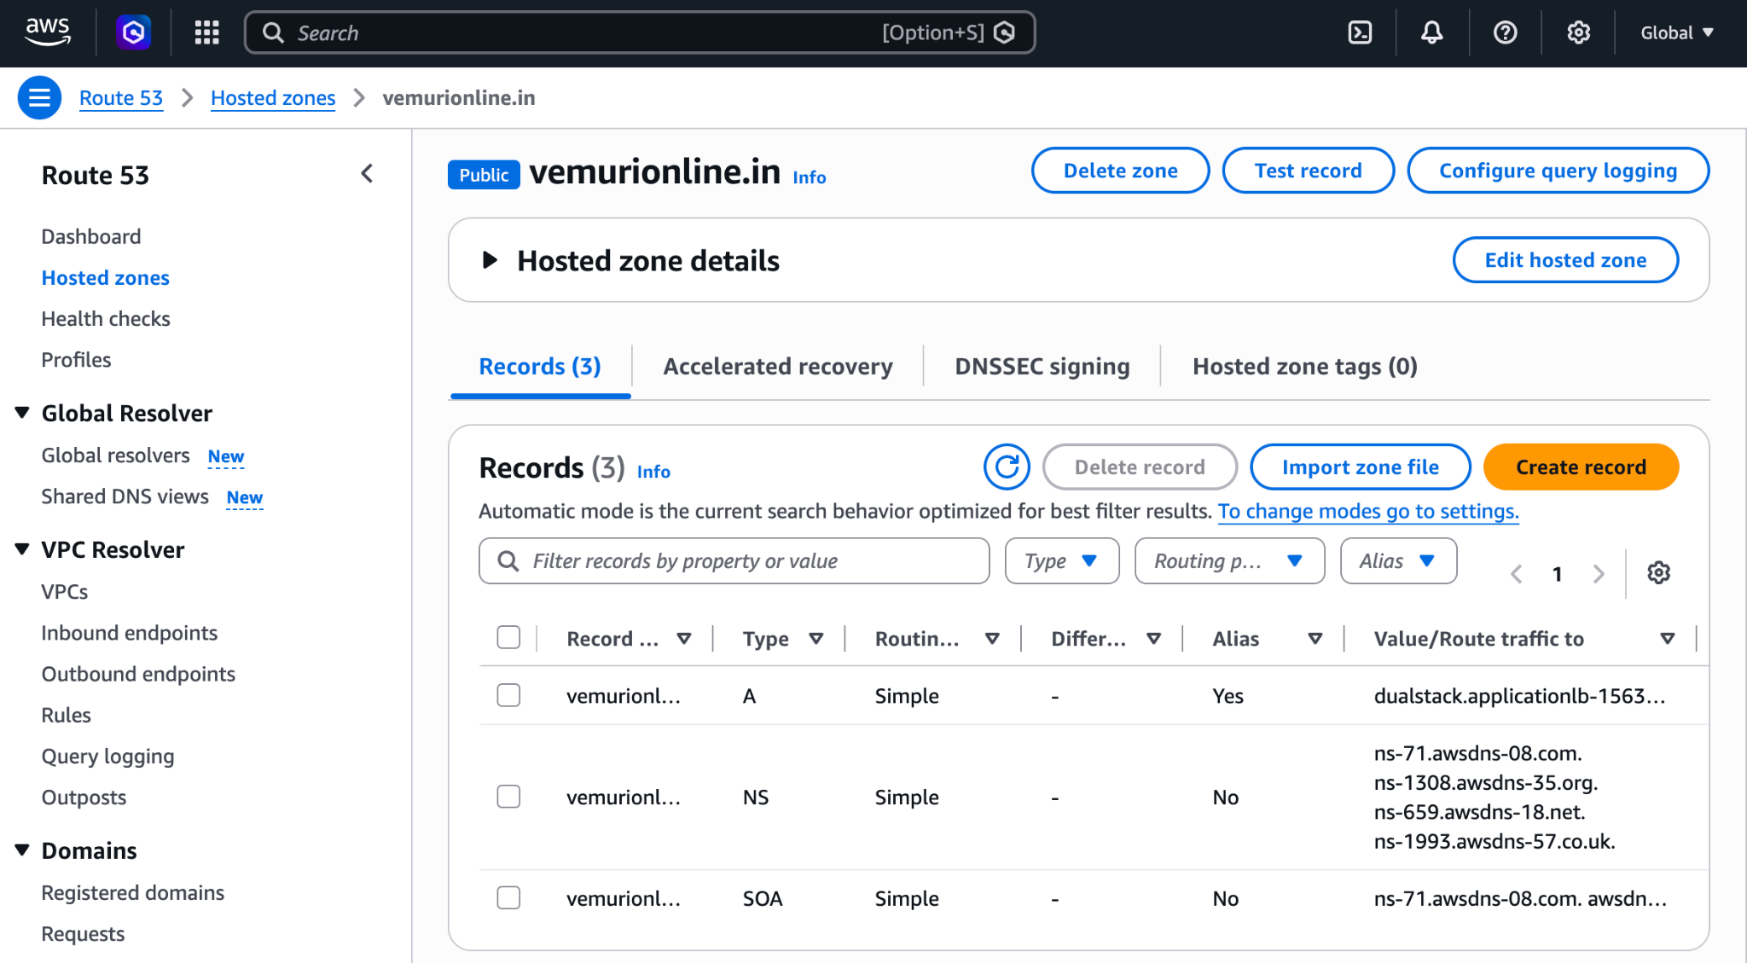
Push the application load balancer logs to S3.
Create The bucket S3 with Unique name and go to Permissions and write the policy
